Closing the Fiscal Gap - Tax and Expenditure Limitations
and Local Debt*

by

John Mikesell, Chancellor’s Professor, Indiana University
Daniel Mullins, Ph.D., EY National Director, State & Local Tax Policy Economics
Marvin Ward, Ph.D., Congressional Budget Office
Chad Smith, Ph.D. candidate, American University / EY

Washington, D.C.
November 19, 2015

Abstract

Tax and expenditure limitations (TELS) have constrain fiscal operations at the state and local level in the US. Whether or not this constraint is beneficial from a democratic perspective, it is important to understand their practical implications. Considerable effort has been directed at the study of the revenue and expenditure effects of TELs. Evidence suggests that TELs depress specific targeted revenue instruments, but there is a lesser effect on spending. One method of reconciling this difference is a shifting of the revenue portfolio to bases that are not constrained by the TEL in question. This has led to a general increase in the use of fees and charges and state aid. However, the yield capacity is finite in a given locale, which suggests that other financing methods would be explored. Debt finance seems a likely method to reduce the fiscal pressure. Comparatively few scholars have evaluated this avenue. Far fewer scholars have evaluated the implications of socioeconomic dynamics specific to the local jurisdiction upon which the TEL acts. To the extent that we would expect different jurisdictions to have different circumstances, it is reasonable to expect that local policymakers would be interested in more than the average effect. This study combines the Census Survey of Government Finances and the USA Counties Database with data on more than 450,000 municipal bond issues between 1984 and 2014 to evaluate the country-wide impacts of TELs on debt activity at the local level. Further, we explore the extent to which debt is used to offset current expenditure responsibilities.

*Prepared for presentation at the National Tax Associations’s,108th National Conference on Taxation, Boston, MA, November 19th – 21st, 2015.

Preliminary Draft.
Not for Quotation.

Introduction

Previous research has shown that limitations on property taxes and general expenditures has brought a shift toward non-tax sources of revenues (fees and charges, state transfers and debt) for financing local public services. Implicit in these structural changes are changes in the distribution of the burdens for financing local government services and likely alterations in service availability, and increased reliance on intergenerational (and intergovernmental) transfers. Because the current limitations have often exempted special districts, it is likely that their outcome will include a greater use of single purpose governmental units for local service delivery. These and other structural changes, often intended as benign adjustments to changing fiscal realities, may reorient the locus of expenditure responsibility. The focus of the research reported in this paper is debt. Specifically, we explore the degree to which the presence of tax and expenditure limitations affect the annual issuance of debt by all governments within urban county areas within all 50 states of the United States. We begin by reviewing the trends in the use of municipal debt by local government (counties, municipalities, townships special districts and school districts) between 1984 and 2014. This is followed by an exploration of the how limits affect debt issuance between the county areas. Do TELS provide incentives to increase the use of debt, alter the distribution between general obligation bonds and revenue bonds, alter the distributions between different purposes or alter the reliance by different types of governments.

This research uses time series data of municipal debt issued by all units of government in approximately 840 metropolitan counties in the United States to begin to assess the effects of state imposed tax and expenditure limitations on the debt use by local government in states enacting these limits. The time frame of the study extends from 1984 through 2014. In addition to detailed county level characters compiled from nearly 450 thousand debt issues, we have merged these data with geographically specific fiscal, demographic and economic data to estimate the effects of these limitations, controlling for the demographic and economic characteristics of each unit of local government.

Taking Stock of the Inventory

We have updated the inventory of the provisions of state-wide limitations on local fiscal autonomy identifies their existence in one form or another in forty-seven states. As of 2014, only Connecticut, New Hampshire, and Vermont had none. Several of these have existed for as long as a century, however, most emerged as a function of the more modern period of "tax revolt" beginning during the 1970's. There are six basic type of limitations: (1) overall property tax rate limits applying to all local governments, (2) specific property tax rate limits applying to specific types of local government (municipalities, counties, school districts and special districts) or specific functions, (3) property tax levy (revenue) limits, (4) General revenue or expenditure increase limits, (5) limits on assessment (base) increases, and (6) full disclosure (truth-in-taxation) requirements. Panel 1 describes each of these forms of limitation.

[Insert Panel 1]

In general, the revenue and expenditure limits are potentially the most individually cumbersome, or binding. Rate limits and particularly assessment limits can be more easily overcome, however, they too can become seriously binding if used in conjunction with one another. The differences in the constraining qualities of their provisions have sometimes resulted in a sub-classification of limitations into type 1 (non-binding) and type 2 (potentially binding). Type 1 limitation include: (i) overall and specific property tax rate limitations, and (ii) assessment increase limitations. Type 2 limitations include: (i) property tax levy limits, (ii) general revenue or expenditure increase limits, and (ii) simultaneous property tax rate and assessment increase limitations. In this paper we will also attempt to identify the effect of more disaggregated categories of limitations applied to specific types of governments in addition to TELs in general. While these categories imply inherent variation in the capacity to constrain, the actual limit is determined by the severity of the constraint and provisions available for circumvention and exclusions. Limitations enacted across states vary dramatically in the severity of the constraint imposed. Within a given state, limitations may prove to be seriously binding constraints on some local governments but not others.

Past Research on Effects

Previous research concerning tax and expenditure limitations has tended to focus on: (i) reasons for voter support, (ii) descriptive summaries and projected effects, and (iii) estimates of their actual fiscal impacts, including their affect of the size of the public sector and its structure. Other has focused on reasons for public support for limitations suggests that they have been supported because of a desire for lower taxes and more efficiency in government, not due to a desire for reduced local public services. Others found that voters support local tax and expenditure limitations because they expect it will lower their tax burden. Some found passage related to economic growth and growth in property taxes and local government's share of the state and local public sector were found more important than demographic or political factors. Still no general desire to limit public services appears active.

Studies of the fiscal effect of tax and expenditure limitations on the state and local sector focus have focused on tax burdens, the impact of limitations on single jurisdictions, and the affects of limitations on the level and mix of government revenues and expenditures in a cross-section of jurisdictions. Others have found effects related to a jurisdictions fiscal capacity and individual property tax burdens. The earlier cross-sectional studies tested only very general effects, with the most prominent focus being the size/scope of government. Comprehensive analysis of overall effects of these limitations on the composition and structure of the state and local public sector also occurred. Few studies have focused specifically on TELs and debt financing.

The research reported here is part of our on-going look at the cross-state, cross-time effects of the tax limitation "movement" on the internal structure of the local public sector across the United States. We expect these effect to become more pronounced over time as jurisdictions adapt to the continued existence of fiscal constraints while faced with ever increasing demands for public services. We continue to analyze broad structural elements within metropolitan areas and across the states and in this paper debt usage in aggregate, across types of governments and by broad category, and by purpose.

Current Trends in Local Government Debt Issuance

INSERT CHAD’S ANALYSIS HERE

Tables and text describing the trends and findings

Research Method

A variety of statistical sources were used to estimate the effects of the imposition of tax and expenditure limitations on the local public sector. The focus of this paper is annual debt issuance across the 50 states between 1984 and 2014 and debt’s use’s relationship to TELs which can be statistically associated with the enacting of these limitations. This analysis is conducted using county areas (and New England county equivalents) as the unit of analysis. Counties areas were chosen as the basic geographic unit because they generally provide the smallest geographic referent containing the universe of government organizations providing local services to individual local populations. Fiscal data were aggregated for all units of local governments within approximately 840 metropolitan counties per year over the period.

The existence and characteristics of local tax and expenditure limitations were identified for each state, and all modern period (1960-2014) enactments of limitations were included in these analyses. This resulted in several time series (or panel) models, each of which include a dependent variable focusing on local government debt structure within individual county areas, independent variables representing various types of tax and expenditure limitations, and demographic and control variables.

Dependent Measures and Expectations.

Because limitations are often directed specifically at property tax revenue and more recently fees, and because they often exempt debt (particularly self-supporting - revenue - debt and debt of special districts) and debt service levies, they may encourage the increased use of debt financing (both traditional and creative) to support public services. While the use of debt (or even its increase) is not inherently bad public policy, the implications may be significant. This is particularly so if it is associated with attempts to circumvent current revenue and spending constraints imposed by limitations rather than the result of rational financial calculation. There are potentially serious implications for longer-term debt service requirements, debt head room and inter-generational equity and allocative efficiency.

- Logged Per Capita General Obligation Bond Issues for All Units of Local Government (GO*PC_LN)
- Logged Per Capita Revenue Bond Issues for for All Units of Local Government (RV*PC_LN)
- General Obligation Proportion of all Bond Issues for All Units of Local Government (GO*PROP)
- Existence of Any Bond Issues from Any Unit of Local Government (BIN_DEBT_ISSUE)

For the first three, note that the descriptions actually describe entire groups of dependent variables. For each, there are aggregate measures, and there are subsets based on issuer type or the purpose of the debt issue. For example, GO_PC_LN captures all GO bonds per capita, while GO_HOUS_PC_LN captures the subset of GO bonds dedicated to housing projects. There are seven issuer types (general municipality, co-op utility, county/parish, direct issuer, district, Indian Tribe, and local authority), and ten debt purposes (development, education, electric power, environmental facilities, general purpose, health care, housing, public facilities, transportation, and utilities). Since the discrete measure (BIN_DEBT_ISSUE) only seeks to capture the existence of any debt, we have no corresponding subsets.

Institutional Constraint Measures (Local Tax and Expenditure Limitations).

For the purposes of this research, a number of different representations of local tax and expenditure limitations are used in different models. In each case, measures are constructed identifying the existence of a limit in the state in which a local unit is located for the year of the observation. One set of models divides limitations into two broad categories outlined above: non-binding (TYPE1) and potentially binding (TYPE2). Each are represented by a binary variable indicating "1" for their presence and "0" otherwise in each state for each year. Because we expect the effects of limitations to grow over time (as their potential to constrain becomes more pronounced), we included a variable in our models which indicates the number of years which have elapsed since the enactment of local potentially binding limits (TYPE2_y) for each state in each cross-section. This model also includes a binary measures interacting the existence of limitations within a central (i.e.,"primary") county. In effect, providing a separate estimate of the effect of the limitations in the core urban counties (TYPE1i, TYPE2i, and TYPE2_yi). The same is done for models exploring the differential effect in county areas experiencing relative fiscal stress. For these models, the measures (TYPE1i, TYPE2i and TYPE2_yi) reflect the interaction of limitations with the existence of county areas in "stress," instead of primary counties.

A second set of models (actually the first presented in the results) limits the representation of local tax and expenditure limits to a binary indicator (LIMITS) of the existence of any limitation in the state in which the local units are located in the year of the cross section (i.e., the existence of either a TYPE1 or a TYPE2 limit). In an attempt to capture the potential interactive effects of binding and non-binding limitations, we also include a binary variable indicating the simultaneous existence of both categories of local limits (BOTH). Urban core and relative stress effects are again represented as separate binary measures (LIMITSi and BOTHi).

A final set of estimate are made using a less aggregate representation of existing limitations (or the "form" of limitation). For these models, limitations are separated into those which are universally applied across local jurisdictions in the form of overall property tax rate limits or limitations on assessments, and those directed at general purpose governments (counties and municipalities) verses school districts. Two dichotomous variables are established indicating the existence of an overall property tax rate limit (RATE_L) and assessment limits (ASMT_L), a second set of measures indicate the existence of specific rate limits, levy limits, revenue limits or expenditure limits applied to general purpose (GP_LMT) or school district (SC_LMT) governments. Again, urban core and fiscal stress effects are represented by an additional set of binary measure (RATE_Li, ASMT_Li, GP_LMTi, and SC_LMTi).

Structural/Demographic Control Measures.

In order to control for the possibility of spurious correlations between our measures of institutional constraints (tax and expenditure limitations) and the spatial, economic, demographic and structural characteristics of county areas, we have included in our models several measures commonly associated with the demand for local public services, the composition of the resource base, and important structural and cost elements. The following "control" variables are included:

Scale and Supply Measures. These include measures of service delivery scale, concentration, stability, and age of infrastructure.

- Population (RESPOP). The total aggregate resident service population of the county area serves as a general measure of the scale of service deliver responsibilities faced by governments in the area, the possible existence of economies of scale, labor market and supply cost structure, urban externalities and governance structure.
- Population Squared (RESPOP2). A polynomial of population is used to allow the non-linear effects of resident population size to be incorporated into the model. The linear relationship between population and dependent measures may diminish or accelerate as population scale increases. This measure allows those relationships to be captured.
- Population Density (DENSITY). Population density (congestion) is also expected to effect the cost and delivery environment of local government services in a manner separate from the over all scale effects of population itself. In order to account for these effects a measure of resident population divided by land area (square miles) has been include in the estimation.
- Population Growth Rate (POPGROW). Service delivery demand/requirements differ between stagnate and dynamic environments. Accelerating expenditures are required in periods of significant growth. The relationship is likely to not be symmetrical, however, as fixed costs to service existing infrastructure and services maintains expenditure pressure in periods of population decline. We have include a measure of the average compound growth rate of the county resident population between each interval of observation to capture this dynamic effect.
- Household Size. Because many services delivered by local governments are delivered to households rather than individuals, we have also included a measure of average household size (PERS_HLD). Incorporation of this measure simultaneously controlling for population, provides a measure of the effect of concentrating or deconcentrating the population into households.
- Pre 1940 Housing Stock (PRE1940). Age of infrastructure and city formation are important determinants of structural characteristics, service delivery costs and needs for maintenance spending. To account for differences in the age of infrastructure within county areas, we include a measure of the proportion of housing units built before 1940.

Socio-Demographic and Demand Measures. Estimating models also attempt to account for the effects of a variety of population and income distribution, and need and demand measures, in isolating the effects of limitations. These include:

- Population Under 17 (PYOUNG). Youth populations reflect both a level of dependency and present critical demands on local governments for education, recreational and, sometimes, police services. A measure of the percentage of the population age 17 or under in the county is used to incorporate these elements.
- Private School Enrollment (PVT_SCH). Enrollment of youth populations in private educational institutions to a degree mitigates the demand for public education and possibly recreation expenditures. This is reflected by a measure of the percent of students enrolled in private primary and secondary education programs.
- Population Over 65 (POP65). The demands of aged populations for public expenditures and even their response to financing arrangement vary from those of other groups. They are often associated with increased demands on medical and social support services. The effects of concentrations of populations in this demographic group is reflected by a measure of their portion of the total population.
- Income Distribution. The income distribution reflects measures of capacity, demand, dependency, and diversity of preferences. We have incorporated four measures in our models to account for these effects. Per capita income(PCINC) of the resident population is employed in order to adjust for variations in structure associated with a relatively more prosperous and developed economic system, demand elasticities, and any centralizing or decentralizing tendencies of the local public sector associated with income. Likewise, differential levels of dependency and social support needs are reflected by a measure of the percentage of families living in poverty within the county (POVERTY). A specific measure of the income of older age populations (average monthly social security payments to social security recipients, PC_SSCI) is included to assess the impact which the relative economic capacity of this segment of the population has on both the resource base and demand for public services. A gross measure of the diversity of the income distribution and thus a gross measure of income derived variations in the demand for public service packages (and therefore for variations in service delivered) is also included in the form of a measure of per capita income weighted by poverty rate (DIVERSITY). Higher levels on this measure imply less income homogeneity and greater demand for variation in public service levels across populations.

Economic Context. Because the structure of the employment base, its magnitude and macroeconomic conditions have implications for both resources and service requirements we have incorporated measures of both economic structure and market environment.

- Employment ratios. Because regional employment is critical to assessing service requirements to meet the needs of daily commuters and to support the infrastructure required to meet the needs of employers, a measure of the ratio of total employment in establishments in the county to the total county resident populations (EMP_RESI) is incorporated. Higher values for this ratio imply a significantly greater demand for locals services, as well as potentially greater relative resource capacity. Also, because employment in different sector has different implications for infrastructure needs and wage levels, we have also incorporated separate measures of the ratio of employment in manufacturing (MANU_RES), retail (RETL_RES) and service (SERV_RES) sectors to resident population.
- Any activity in debt markets is materially influenced by the cost of capital. For this reason, we include two measures of interest. The first seeks to provide a sense of the prevailing interest rate. Since debt issues are generally long term, we have selected the inflation-adjusted 30-year Treasury rate (REAL_RATE). We also expect spatial variation in the capacity to service debt, and therefore variation in the price charged by the market. The raw data feature broad coverage of interest costs in two avenues. True Interest Cost (TIC) is our preferred measure. It is calculated as the interest rate, compounded semi-annually, that must be charged to make equivalent the outlay for a bond in year 0 and the sum of the future stream of payments over the term. It is available for most, but not all debt issues in the Reuters data. A secondary measure is the Net Interest Cost (NIC), which is the average annual interest rate an issuer actually pays. We developed an inflation-adjusted composite variable (R_CTY_INT) which combines these costs (TIC values being adjusted to annual rate). The model includes the difference between the prevailing and county interest rates (REAL_RATE – R_CTY_INT) as a measure of the relative capital advantage of a given county (R_CTY_INT_DIFF). We also included the annual change in the prevailing rate to capture issues incited by market shifts (REAL_RATE_CHANGE).
- To the extent that the availability of capital can decrease dramatically during a recession, even if interest rates are kept low, some measure of the business cycle is appropriate. Consequently, we include a binary measure for recessionary years (BIN_REC) which equals one when the majority of months in a given year fall into a recessionary period as defined by the National Bureau of Economic Research.

Fiscal Environment Measures

The decision of any county to issue debt is driven by desires to either 1) efficiently couple the costs and benefits of durable assets, or 2) satisfy constituent preferences in the absence of sufficient cash flows. There are strong efficiency arguments for the former, but in practice, the latter is often more salient. As such, it behooves us to control for the fiscal circumstances that provide the operating context for a given issuer.

- The amount of debt an issuer can hold is driven by the market's perception of its ability to service that debt. The capacity of a government to service debt generally rises with the revenue collected, so GEN_REV controls for total general revenue for each county in each year.
- In the same vein, revenue is collected from taxpayers. The ability of taxpayers to service new revenue requests is likely to change with different levels of tax effort. Consequently, we have included the ratio of general revenue to personal income as a control measure (TAX_EFFORT).
- If a government is experiencing a revenue shortfall, powerful incentives may exist to cover the gap with a debt issue. Indeed, this idea is the foundational motivation for this analysis. To account for this, we have developed a fiscal stress measure which captures the difference between general revenue and direct general expenditures. This measure (OSRC_GAP) is then divided by direct general expenditures to normalize it across counties.
- The ability to carry new debt will depend on the market's perception of carrying capacity. This capacity depends on revenue, but also pre-existing debt. For that reason, the model controls for total debt outstanding (TOT_DEBT_OUTST).

Complete Model.

The effects of tax and expenditure limitations on new debt issues are evaluated based upon the following general model.

debt_issue ~ TELs + structural_supply + structural_demand + econ_context + fiscal_environ

The dependent variable set includes three groups of 18 (total, all issuer types, and all purposes for GO debt, revenue debt, and GO proportion of total debt). There are three bases specifications based upon different operationalization of TELs, and four fixed effect combinations (pooled, state effects, year effects, both). This leads to a total of 648 models to be estimated. Only the “topline” models will be presented in any detail, but aggregate views of TEL impacts across all models will be shown as well. An additional binary choice probit estimator is employed to evaluate TELs as a driver of the debt issue decisions in isolation from the volume of the debt issue itself.

Each is estimated using pooled cross-sectional time series techniques, with the institutional and control variables regressed against the dependent variables. The design employed is a standard fixed effect time-series regression model with BEA region clustered standard errors, with binary variables representing each state in order to hold the unique structural qualities of each state.
Patterns across time are addressed in the model covariates by way of recessionary measures and interest rate dynamics.

These models use a quasi-experimental time-series design in which the enactment of limitations in differing states at differing times represents the existence of multiple treatments and where the absence of limitations in some states during a subset of years and across all years in other states act implicitly as a control group. The results obtained can be considered a conservative assessment of the effects of the enactment of limitations and the limitation movement.
Results

The results of the statistical models are presented in Tables 1 through 4. In each case, these tables display only the results for the institutional constraint measures, omitting results for the control measures and the state fixed effect parameters. While the parameter estimates for these control variables and individual state fixed effects are interesting in their own regard, because our specific focus is on the effects of tax and expenditure limitations (and due to the table size requirements to do otherwise), it seems appropriate to limit the presentation to only the estimated coefficients for the institutional constraints.

All models have been estimated in exponential from (i.e., with the dependent variable transformed as its natural log) using WLS. To focus the analyses on the impact of limitations on service populations, all models were weighted by population density. The models can be interpreted as percentage change in the dependent variable associated with the imposition of a limitation or its duration over time.

Alternative Debt Financing

Limitations imposed state-wide to constrain government's ability to generate revenue and make expenditures do nothing to constrain demands and needs for public services. In the face of continuing demands, governments would be expected to find alternative means of satisfying resource needs. Previous research has shown a significant increase in fees and intergovernmental transfers in the face of limitations. In addition to resources from these sources, because limitations are often focused on property taxes with specific exemptions for debt service, another possible avenue would be the issuance of debt to finance public projects / services which would have been funded out of general revenues were there not constraints. Further, because general debt often faces its own constraint, this pressure for government services may be translated into increases usage of non-guaranteed forms of debt and contractual financing instruments (technically outside the definition of debt) in the form of leases and certificates of participation.

Tables 1 and 2 explore the issuance of debt for both general obligation and revenue bonds (by all local issuer types in a given county). Table 3 addresses the composition of debt issues by county, and Table 4 evaluates TELs as drivers of any debt issuance by a county in a given year. Note that the tables actually hold the results of three different models:

Type models TELs with TYPE1 (non-binding), TYPE2 (potentially binding), and TYPE2_Y (years since TYPE2 enacted).

Aggregate models TELs with BOTH (TYPE1 and TYPE2) and LIMITS (TYPE1 or TYPE2)

High Resolution models TELs with RATE_L (overall property tax rate limit), ASMT_LMT (overall assessment limit), GP_LMT (limit applied to general purpose governments), and SC_LMT (limit applied to school districts)

Per Capita General Obligation Debt Issues (Table 1)

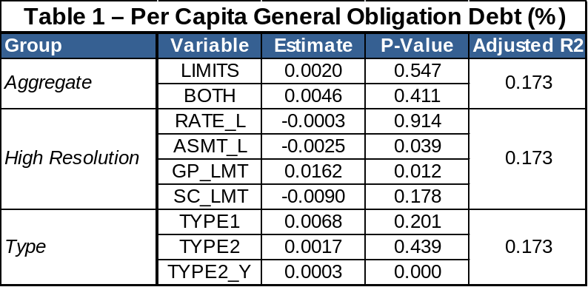

Neither of the per capita model sets explained a significant portion of the variation in debt issuance by count. However, at approximately R² = 0.17, the model runs using logged per capita GO debt as the dependent featured the lowest fit of all models run in this analysis. Furthermore, the magnitude of the effect is quite small. Nevertheless, the direction of estimates with clean signals is of interest from the perspective of understanding trends in the larger research program.

None of the effect sizes moves debt issue volume by more than 0.02%. Among Type variables, neither the existence of non-binding or potentially binding limits has any clear effect. However, each additional year of the cumulative effect associated with the enactment of a potentially binding limit is positively related with debt issuance. Though small, this effect accords with the intuition laid out earlier. Higher levels of constraint are associated with the need to seek other means of financing, and the constraint imposed by TELs is expected to increase over time. Debt is an available option for local public officials seeking to finance projects or services in a revenue constrained environment.

Neither of the Aggregate TEL variables have a meaningful effect, but within the High Resolution TEL variables, both overall assessment limits and limits applied to general purpose governments are statistically significant. The general purpose government limit is the strongest in the model group at 0.02%, and it also increases the likelihood of a debt issue. Assessment limits, on the other hand, are actually associated with reductions in debt issues. This may be a consequence of their non-binding nature, but it is unlikely to be a direct consequence. Rather, given the weakness of the constraint, this outcome may be a function of an indirect relationship between the two variables. That is, since assessment limits can be circumvented, the limit does not come into play with regards to debt issues decisions. It is plausible that debt just is not as attractive at lower levels of fiscal stress.

Per Capita Revenue Debt Issues (Table 2)
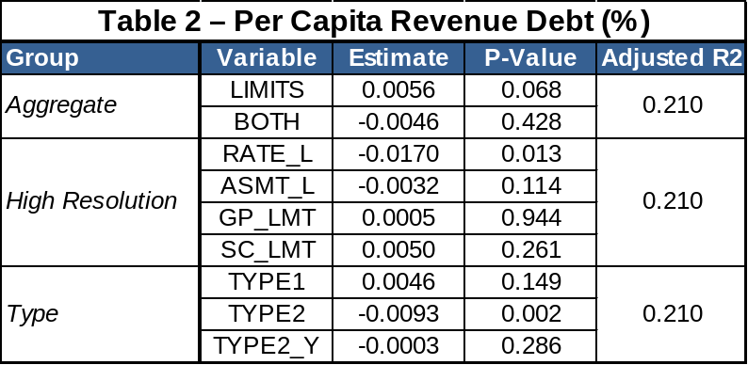

Interestingly, the output for the revenue debt models contrasts strongly with the general obligation models. Among the Type variables, it is the existence of potentially binding limits that is significant, and even then it is negative. Given that both the existence and duration of potentially binding TELs are associated with reductions in revenue debt while also being associated with increases in GO debt, this has the feel of a compositional shift being more likely when constraints are binding.

In the Aggregate models, the existence of either limit is associated with increases in revenue debt, while the existence of both is associated with decreases (though insignificantly so from a statistical standpoint). The combination weakly suggests that it is indeed TYPE1 (non-binding) limits that are actually associated with increases in revenue debt. This narrative fits with the findings discussed so far. It could be argued that unconstrained counties are more likely to deploy debt in service of financing revenue-generating assets, which is supported with a strong efficiency rationale from the perspective of matching benefit and cost streams. Constrained counties, by contrast, may be more willing to rely on “full faith and credit” general obligation issues to finance activities that have a weaker efficiency rationale.

That non-binding rate and assessment limits (High Resolution variables) are associated with reductions in both general obligation and revenue debt is unexpected in this context. This conflict is attenuated by the fact that the noise in the estimates blocks both rate and assessment limits from strong agreement across the general obligation and revenue models.

General Obligation Proportion of Total Debt Issues (Table 3)

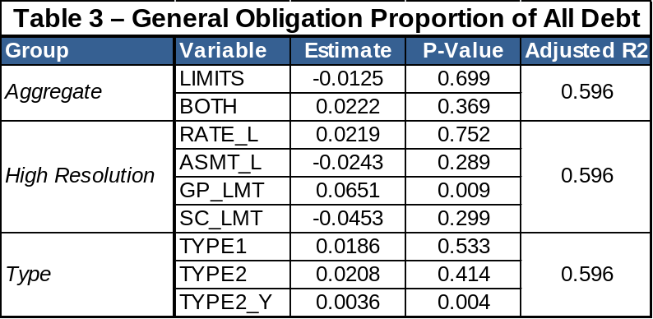

Finally, the GO proportion models support the compositional narrative posited above. The cumulative effect of potentially binding TELs (a Type variable) is associated with greater proportions of general obligation debt being issued. The magnitude of this effect is approximately 0.4 percentage points per year and it is a statistically clear signal. Like the general obligation models, the existence variables in the Type and Aggregate variables have no clear effect.

Among the High Resolution variables, only the existence of the limit on general purpose governments is material. It has the largest effect of any variable in the all of the models shown, increasing the proportion of debt issues by 6.5 percentage poitns. This finding supports the positive relationship between general purpose government limits and general obligation debt in the first set of models.

Discrete Issue of Any Debt - GO or Revenue (Table 4)

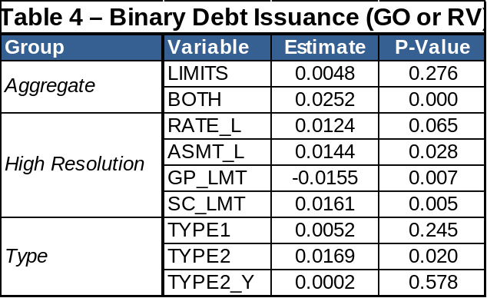

In this final model set, we seek to evaluate whether or not TELs were meaningful predictors of discrete choices to issue debt. As will quickly become apparent, this grouping provides an entirely different view. Among Type variables, only the existence of potentially binding TELs (TYPE2) stands out. By contrast, the previous model sets highlighted the cumulative effect (TYPE2_Y). Not only is it among the clearer signals relative to the other covariates within the Type model, existence of a potentially binding TEL increases the chance of debt issue by 2%. The finding that both TYPE1 and TYPE2 limits (Aggregate) increase the likelihood by 2.5% while the variable capturing the existence of either (LIMIT) has no discernible effect reinforces the importance of TYPE2 TELs in the decision to issue debt.

This apparent conflict is reconciled by considering the nature of the dependents. In models with a continuous dependent, the estimator is able to draw distinctions among counties with potentially binding limits. Out of all of the TYPE2 counties, some have had these limits for a longer period and the effect on their fiscal behavior can be parsed out based upon variance in the amount of debt issued. If the dependent is instead binary, no such resolution is available. This places the weight of distinction not on the duration of the potentially binding limit (TYPE2_Y), but rather on the existence itself (TYPE2).

Perhaps the most surprising findings are the salience and direction of the specific limits identified in the High Resolution model. All types of limits considered are statistically significant to a degree. Furthermore, they break strongly from the trend set in the other models. Overall rate (RATE_L), overall assessment (ASMT_L), and school district limits (SC_LMT) all increase the likelihood of debt issue, while the limit on general purpose governments reduce this likelihood.

“Many Model” Exploration of TEL Impacts

“Economists customarily speak of these [models] as ‘good’, ‘bad’, ‘valid’, and ‘invalid’. Given the distinction between the data generating process and confluent relations, it would be more to the point to think of these econometric calculations themselves as observations of the confluent relations. As such they may be illuminating or useful or neither, but not valid or invalid.” (emphasis added)

Hoover is suggesting that it is easy to interpret empirical relationships that are a function of both the underlying data generating process and the model identification approach as solely a function of the former. The remedy is to view each model as an econometric observation. To this end, in addition to the topline results above, the existence of Type, Aggregate, and High Resolution TELs were evaluated against the entire range of the 648 specifications identified in the discussion of the Complete Model. The goal was to identify trends in debt issues, including the impact on subsets of debt by issuer type and purpose. Summarizing these effects provides some sense of the stability of these estimates. The approach taken here is to plot the kernel density associated with each set of TEL variable estimates.

Each of the following plots contains several three primary features. The first is the aforementioned kernel density plot. There is one such density plot for each variable considered, and it reflects the 216 coefficient estimates associated with the variable group (Type, Aggregate, or High Resolution). The second feature is the collection of colored data points. These are “highlights” that capture the four coefficient estimates that correspond to models using total debt of a certain type as the dependent (e.g. total general obligation debt per capita as opposed to general obligation debt for only housing projects). There are four points to reflect four models with different fixed effect arrangements (pooled, state, year, and both). The third feature is the rug plots, which simply provide a more detailed idea of the overlapping coefficient distributions.

There are two major takeaways from each plot. The first is the central tendency of the kernel density. If the central tendency of a density plot is to the right of the dotted zero line, the TEL variable in question is more often associated with increased debt issue volume across a wide and varied range of specifications. The second takeaway concerns the width of the kernel plot, which may also be reflected in the spread of the highlighted data points. This speaks to the variance in the impact of each TEL. In both cases, the scale of the effect is given by the x-axis, which is labeled by percent changes in debt volume.

The plots that follow focus solely on the issuance of per capita debt. There are six in total, two for each variable group so that the impact on general obligation and revenue debt may be compared.

Type Variables Across All Specifications

The first plot captures TELs by type, and it largely accords with the findings in our topline models. Both non-binding and potentially binding limits straddle the zero line for total general obligation debt, which accords with the noise seen for these variables in Table 1. The only clean signal comes from the variable capturing the years since the enactment of the potentially binding limit (TYPE2_Y), which can be seen by the small, consistent offset in the positive direction.

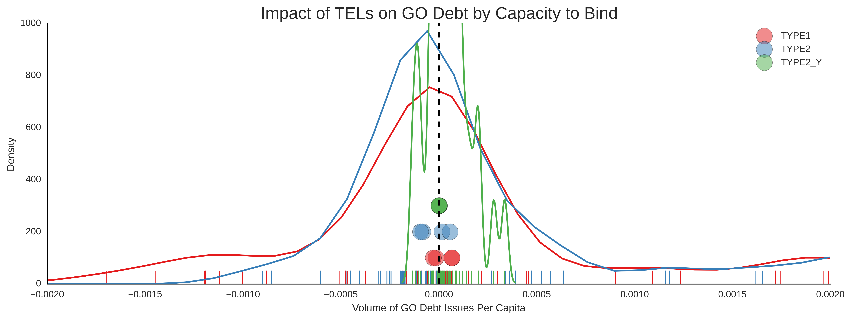
The second plot agrees with Table 2 to the extent that potentially binding TELs are materially associated with a reduction in total revenue debt issued per capita. The width of the kernel density reveals, however, that while this may be true for total revenue debt, there is a great deal of variance for revenue debt subsets. Years since TYPE2 enactment, however, are much more precise. The issue here appears to be that the estimate is so close to zero that the comparatively small variance in the estimates covers up the effect. Non-binding issues, by contrast, still exhibit wide variance and no clear effect at all.

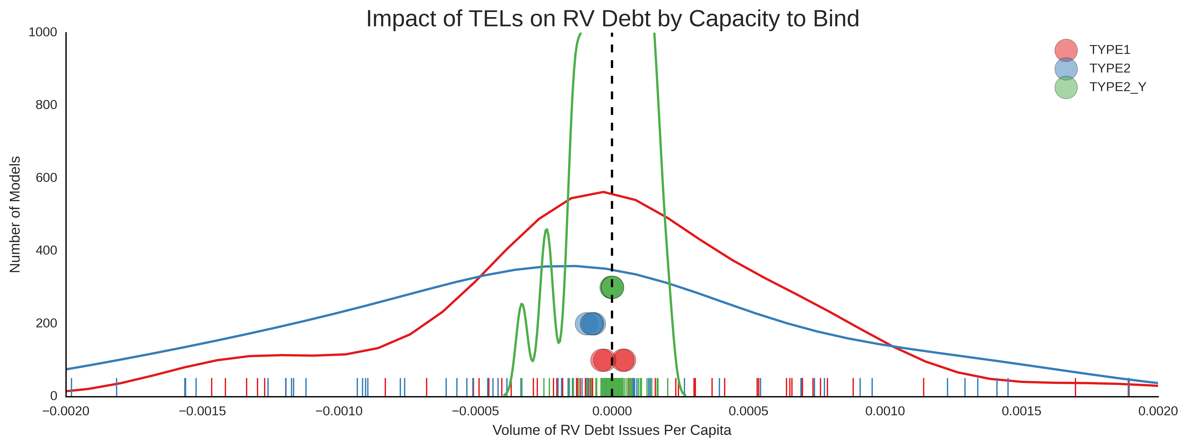

Aggregate Variables Across All Specifications

The third plot affirms Table 1 insofar as the effect of the existence of both limits has been completely covered up by wide variance in the estimates. In this context, it is curious that all four estimates associated with different fixed effects still come out positive. The variable the captures the existence of either limit (LIMITS), by contrast, straddles both sides of the zero line. The arrangement of the data highlights suggests that variance in BOTH may have more to do with the set of debt measured, while the variance in LIMITS may have more to do with specification.

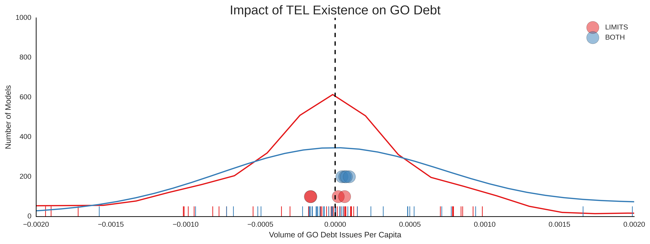

The fourth plot presents an interesting contrast from Table 2, which identified the existence of either limit as clearly associated with increased issuance of revenue debt. The direction of this effect is preserved, but the variance across different sets of debt is extremely wide. The fact that the kernel density plot for LIMITS extends so far to the right suggests that significantly larger estimates may be available for some of the revenue debt subsets. By contrast, the impact of the existence of both non-binding and potentially binding limits has a very well-formed density curve with the bulk of the mass clearly in the negative region. While the direction agrees with the estimate in Table 2, the kernel plot suggests the most of the models have a much clearer signal.

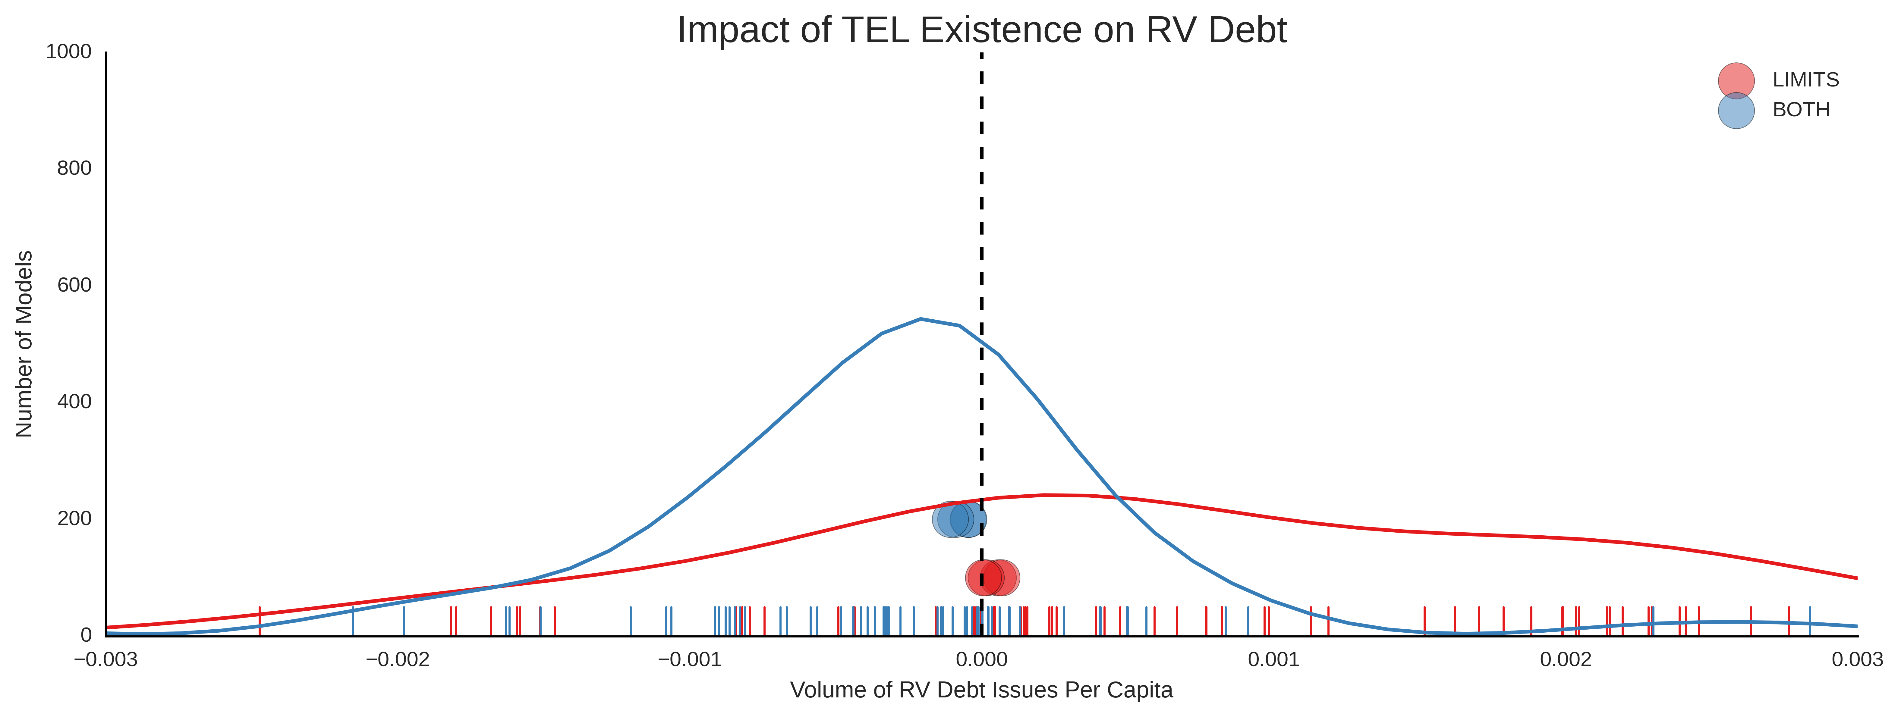

High Resolution Variables Across All Specifications

The fifth plot suggests that the impact of overall rate limits (RATE_L), overall assessment limits (ASMT_L), limits on general purpose governments (GP_LMT), and limits on school districts (SC_LMT) are essentially ambiguous at best. The central tendency of each of the four variables is quite close to zero, and indeed, the highlighted data points capturing total general obligation are fairly sensitive to the fixed effect regime used. This undercuts the narrative of clear impacts from ASMT_L and GP_LMT in Table 1.

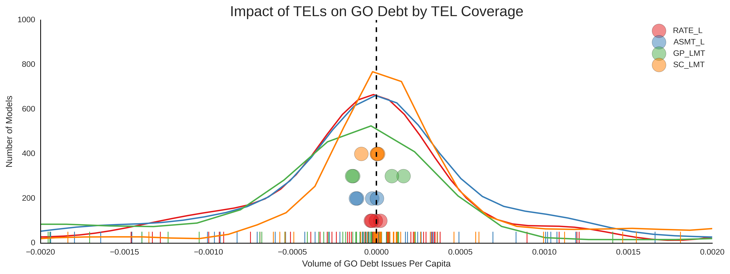

In the sixth and final plot we see a very similar story. The difference here is the variance in the estimates is much greater. Indeed, this is precisely the type of situation in which we should be cognizant of the bias associated with a particular model specification. Focusing on any one of the models in this group may have provided a very misleading picture of the impact of these TEL variables on debt issuance.

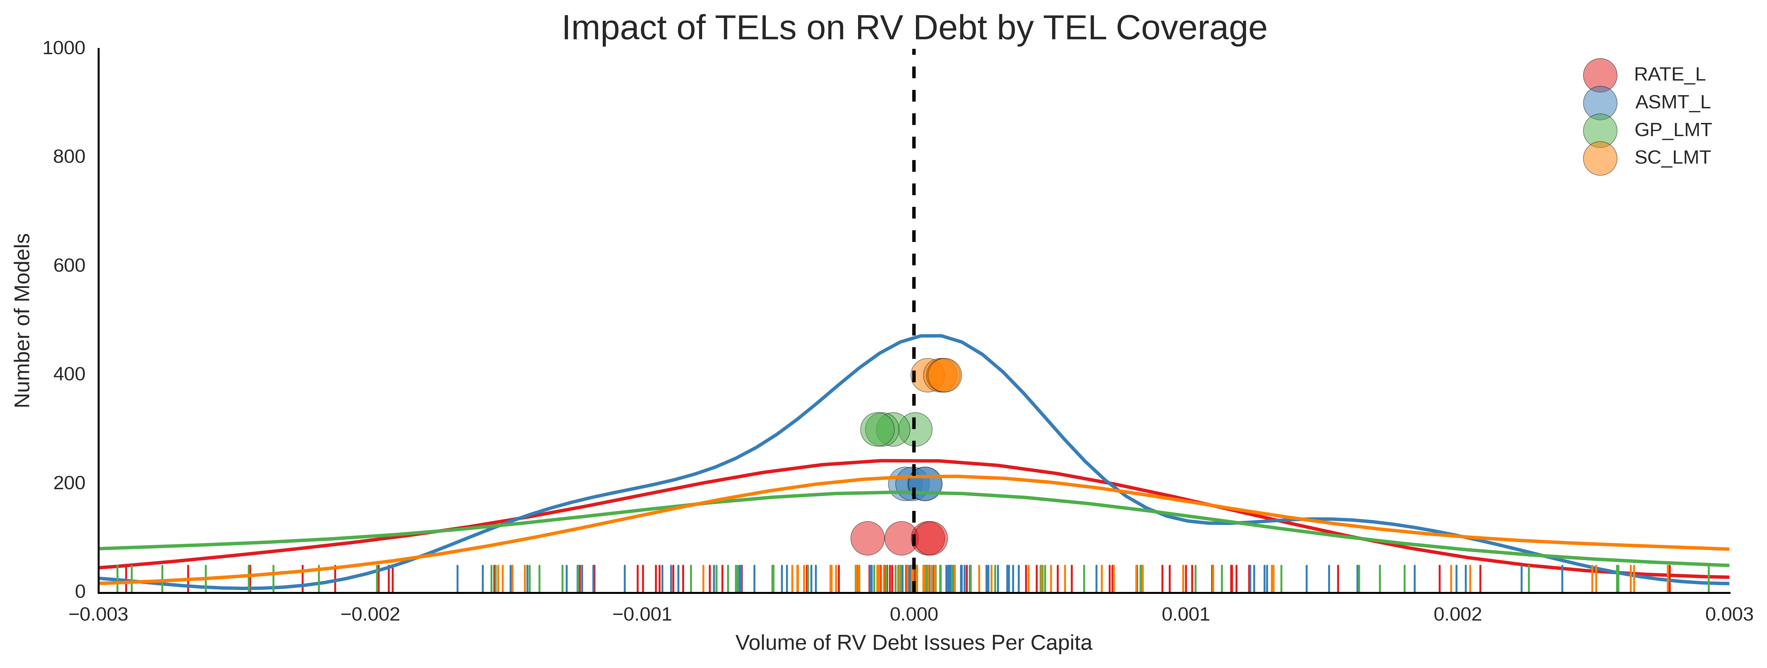

Discussion and Conclusions

The results of our analyses suggest that tax and expenditure limitations do have statistically significant and, due to compounding, potentially important substantive effects on the long-term mechanisms of finance. They suggest that different forms of limitations have different overall effects, and that these effects vary based on the type of issuer or debt purpose. Our basic results can be summarized as follows:

Tax and expenditure limitations are associated with an overall increase in the use of debt, but the form of the limit is significant. Specifically, potentially binding limits increase the likelihood of debt issues, while non-binding issues are not clearly associated with such an increase.

The type of tax and expenditure limitation in place has implications for the composition of debt issued by a county in a given year. Potentially binding TELs are associated with increased proportions of general obligation debt while non-binding TELs are associated with decreases in proportions of general obligation debt. The latter is likely an artifact of a relatively unconstrained fiscal position as opposed to just the existence of the TEL.

The duration of a potentially binding constraint is the most consistent driver of increases in general obligation debt. This accords with intuition insofar as we expect binding TELs to become more constraining over time. Greater levels of constraint and associated fiscal stress are likely to encourage the use of general obligation debt that may not be as defensible on efficiency grounds as revenue bonds for revenue generating projects.

The type of issuer or purpose of the debt issue can materially alter the estimate of TEL impact. Furthermore, in some cases, the specification (e.g. different fixed effect approaches) can exacerbate this variance. This provides a cautionary tale against extrapolating the effects of a single model in a definitive manner.

PANEL 1
TYPES AND CLASSIFICATION OF TAX AND EXPENDITURE LIMITATIONS

Overall Property Tax Rate Limitations: Limits on property tax rates are the most common form of TEL. If the limit is on overall property tax rates, a rate ceiling is set that cannot be exceeded without a vote of the electorate, and applies to the aggregate tax rate of all local government.

Non-binding: easily circumvented through alterations in assessment practices.
Potentially Binding: if coupled with a limit on assessment increases.

Specific Property Tax Rate Limit: Same as for overall property tax rate limits except it applies to specific types of local jurisdictions (for example, school districts or counties) or narrowly defined service areas.

Non-binding: can be circumvented through alterations in assessment practices or, in the case of specific services, through inter-fund transfers (fungibility).
Potentially Binding: if coupled with a limit on assessment increases.

Property Tax Levy Limit: This type of limitation constrains the total amount of revenue that can be raised from the property tax, independent of the property tax rate. It is often enacted as an allowable annual percentage increase in the levy.

Potentially Binding: the fixed nature of the revenue ceiling makes this, ceteris paribus, a more formidable constraint, however, it can be limited through a diversification of revenue sources (which is its underlying intent).

General Revenue or General Expenditure Increases: In the case of revenue limits, these cap the amount of revenue that can be collected, while expenditure limits attempt to constrain spending during the fiscal year. These are often indexed to the rate of inflation.

Potentially Binding: the fixed nature of the revenue or expenditure ceiling makes this, ceteris paribus, a more formidable constraint.

Limits on Assessment Increases: Since the property tax collected is a function of the assessed valuation of the property, and the tax rate, this type of limitation controls the ability of local governments to raise revenue by reassessment of property or through natural or administrative escalation of property values.

Non-binding: the constraint is easily avoided through an increase in property tax rate
Potentially Binding: if coupled with an overall or specific property tax rate limit.

Full Disclosure - Truth in Taxation: These types of limitations generally require some type of public discussion and specific legislative vote prior to the enactment of tax rate or levy increases.

Non-Binding: requires only a formal vote (generally a simple majority) of the local legislative body to increase the tax rate or levy.

Source: Phil G. Joyce and Daniel R. Mullins, "The Changing Fiscal Structure or the State and Local Public Sector: The Impact of Tax and Expenditure Limitations," Public Administration Review, vol. 51 (May/June 1991): 240-253.
TABLE 4e
EFFECT OF TAX & EXPENDITURE LIMITATIONS
ON LOCAL FISCAL AND GOVERNANCE STRUCTURE
(Pooled Cross-Sectional Time Series Regression Results)
Dependent  Variables  Independent  Variable
  Per Capita  Total Long-Term Debt Outstanding -- All Units of Local Government  (log transformation, density wt.) |  |  |  |  | Per Capita  Non-Guaranteed Long-Term Debt Outstanding -- All Units of Local Government  (log transformation, density wt.)
  All | Primary Interact | Primary | Fringe | Stress Interact | All | Primary Interact | Primary | Fringe | Stress Interact
LIMITS | -.141^ | -.158^ | -.123^ | -.164^ | -.110^ | -.081~ | -.029 | -.090 | -.041 | .049
BOTH | .029 | .034 | .161^ | -.106~ | -.198 | -.079 | -.113 | .101 | -.300^ | -.413^
LIMITSi |  | .028 |  |  | -.061~* |  | -.087~ |  |  | -.268^
BOTHi |  | -.007 |  |  | .457^ |  | .054 |  |  | .672^
Adj R-sq/N | .42/ 4650 | .42/ 4650 | .48/ 1854 | .44/ 2796 | .42/ 4650 | .40/ 4500 | .40/ 4500 | .50/ 1848 | .32/ 2652 | .41/ 4500
TYPE1 | -.004 | -.084* | .095* | -.097* | -.041 | .116^ | .045 | .228^ | .000 | .091
TYPE2 | -.112^ | -.068 | -.085* | -.153^ | -.134^ | -.148^ | -.079 | -.135* | -.150~ | -.156*
TYPE2_y | -.004* | -.004 | -.004 | -.004 | -.006* | -.010^ | -.007 | -.008* | -.011* | -.007
TYPE1i |  | .150^ |  |  | .101^ |  | .125* |  |  | .067
TYPE2i |  | -.066 |  |  | .036 |  | -.102 |  |  | .009
TYPE2_yi |  | -.001 |  |  | .003 |  | -.006 |  |  | -.006
Adj R-sq/N | .42/ 4650 | .42/ 4650 | .48/ 1854 | .44/ 2796 | .42/ 4650 | .41/ 4500 | .41/ 4500 | .50/ 1848 | .36/ 2652 | .41/ 4500
RATE_L | .254^ | .095 | .381^ | .027 | .293^ | .655^ | .544^ | .827^ | .415 | .644^
ASMT_L | .203^ | .136 | .231^ | .181 | .139~ | .337^ | .261 | .424* | .230 | .290*
GP_LMT | -.119^ | -.159^ | -.052 | -.169^ | -.119^ | -.015 | -.018 | .060 | -.060 | .044
SC_LMT | -.118^ | -.049 | -.212^ | -.045 | -.133^ | -.314^ | -.208^ | -.455 | -.154 | -.295^
RATE_Li |  | .207* |  |  | -.154 |  | .155 |  |  | -.097
ASMT_Li |  | .101 |  |  | .250* |  | .121 |  |  | .162
GP_LMTi |  | .088~ |  |  | .010 |  | .014 |  |  | -.121
SC_LMTi |  | -.130^ |  |  | .024 |  | -.172* |  |  | -.007
Adj. R-sq/N | .42/ 4650 | .42/ 4650 | .50/ 1854 | .44/ 2796 | .42/ 4650 | .41/ 4500 | .41/ 4500 | .52/ 1848 | .36/ 2652 | .41/ 4500
"~" = p-value of <= .10; "*" = p-value of < =.05; "^" = p-value <= .01.
Parameter estimates for 20 control variables and 54 state and year effects were included in the estimated models but omitted from the results presented in the table.

TABLE 4f
EFFECT OF TAX & EXPENDITURE LIMITATIONS
ON LOCAL FISCAL AND GOVERNANCE STRUCTURE
(Pooled Cross-Sectional Time Series Regression Results)
Dependent  Variables  Independent  Variable
  Ratio of Total Non-Guaranteed
  Long-Term Debt to Total Long-Term Debt Outstanding
  (density wt.)
  All | Primary Interact | Primary | Fringe | Stress Interact
LIMITS | .039^ | .051^ | .031*^ | .041^ | .067^
BOTH | -.057^ | -.078^ | -.039* | -.081^ | -.109^
LIMITSi |  | -.020~ |  |  | -.060^
BOTHi |  | .037~ |  |  | .105^
Adj R-sq/N | .50/ 4500 | .50/ 4500 | .60/ 1848 | .46/ 2652 | .50/ 4500
TYPE1 | .019 | .007 | .046^ | -.005 | .017
TYPE2 | -.001 | .022 | -.021 | .021 | .003
TYPE2_y | .000 | -.001 | .001 | -.002~ | .001
TYPE1i |  | .021~ |  |  | .004
TYPE2i |  | -.036~* |  |  | -.008
TYPE2_yi |  | .001 |  |  | -.002
Adj R-sq/N | .50/ 4500 | .50/ 4500 | .60/ 1848 | .45/ 2652 | .50/ 4500
RATE_L | .168^ | .169^ | .187^ | .162^ | .147^
ASMT_L | .099^ | .113^ | .086^ | .113^ | .114^
GP_LMT | .037^ | .038^ | .046^ | .032~ | .048^
SC_LMT | -.052^ | -.037* | -.075^ | -.043* | -.041^
RATE_Li |  | .005 |  |  | .055^
ASMT_Li |  | -.020 |  |  | -.064
GP_LMTi |  | .000 |  |  | -.025
SC_LMTi |  | -.024 |  |  | -.015
Adj. R-sq/N | .51/ 4500 | .51/ 4500 | .61/ 1848 | .46/ 2652 | .51/ 4500
"~" = p-value of <= .10; "*" = p-value of < =.05; "^" = p-value <= .01.
Parameter estimates for 20 control variables and 54 state and year effects were included in the estimated models but omitted from the results presented in the table.

TABLE 4g
EFFECT OF TAX & EXPENDITURE LIMITATIONS
ON LOCAL FISCAL AND GOVERNANCE STRUCTURE
(Pooled Cross-Sectional Time Series Regression Results)
Dependent  Variables  Independent  Variable
  Total Per Capita  New Debt Issued During Year  -- All Units  (log transformation, density wt.) |  |  |  |  | Total Per Capita  New Debt Issued During Year  -- Only Issuing Units  (log transformation, density wt.)
  All | Primary Interact | Primary | Fringe | Stress Interact | All | Primary Interact | Primary | Fringe | Stress Interact
LIMITS | -.138 | -.093 | -.255^ | -.051 | .033 | -.019 | -.083 | -.082 | -.037 | -.090
BOTH | .280* | .391* | .369* | .358~ | .058 | .300^ | .383^ | .365^ | .207 | .108
LIMITSi |  | -.080 |  |  | -.209* |  | .103 |  |  | .130~
BOTHi |  | -.198 |  |  | .451^ |  | -.140 |  |  | .385^
Adj R-sq/N | .32/ 4662 | .33/ 4662 | .32/ 1860 | .33/ 2802 | .32/ 4662 | .26/ 4230 | .26/ 4230 | .31/ 1812 | .27/ 2418 | .26/ 4230
TYPE1 | .008 | .036 | -.044 | .154 | .069 | .087 | .007 | .091 | .076 | .002
TYPE2 | -.014 | .088 | -.100 | .015 | .123 | .002 | .096 | -.027 | -.051 | .073
TYPE2_y | .001 | .000 | .006 | .001 | -.014 | .012^ | .008 | .013* | .009 | -.004
TYPE1i |  | -.063 |  |  | -.112 |  | .153~ |  |  | .228^
TYPE2i |  | -.161 |  |  | -.257~ |  | -.148 |  |  | -.153
TYPE2_yi |  | .000 |  |  | .027^ |  | .008 |  |  | .030^
Adj R-sq/N | .31/ 4662 | .32/ 4662 | .31/ 1860 | .34/ 2802 | .32/ 4662 | .26/ 4230 | .26/ 4230 | .31/ 1812 | .27/ 2418 | .26/ 4230
RATE_L | .413 | .410 | .450 | .963~ | .424 | .389~ | .172 | .415 | .329 | .465*
ASMT_L | .219 | .005 | -.011 | .364 | .126 | .235 | .213 | .149 | .449 | .234
GP_LMT | -.286^ | -.196 | -.427^ | -.138 | -.154 | -.196* | -.180~ | -.239* | -.149~ | -.252^
SC_LMT | .203~ | .232 | .199 | .153 | .116 | .251^ | .223* | .167 | .241 | .153
RATE_Li |  | -.014 |  |  | -.008 |  | .284 |  |  | .014
ASMT_Li |  | .344 |  |  | .268 |  | .027 |  |  | .010
GP_LMTi |  | -.186 |  |  | -.287* |  | -.037 |  |  | .104
SC_LMTi |  | -.008 |  |  | .207 |  | .052 |  |  | .145
Adj. R-sq/N | .32/ 4662 | .32/ 4662 | .31/ 1860 | .34/ 2802 | .32/ 4662 | .26/ 4230 | .26/ 4230 | .31/ 1812 | .27/ 2418 | .26/ 4230
"~" = p-value of <= .10; "*" = p-value of < =.05; "^" = p-value <= .01.
Parameter estimates for 20 control variables and 54 state and year effects were included in the estimated models but omitted from the results presented in the table.

See, for example, Philip G. Joyce and Daniel R. Mullins, "The Changing Fiscal Structure of the State and Local Public Sector: The Impact of Tax and Expenditure limitations," Public Administration Review 51 (May/June, 1991), 3: 240-253; Daniel R. Mullins and Philip G. Joyce, "Tax and Expenditure Limitations and State and Local Fiscal Structure: An Empirical Assessment," Public Budgeting & Finance 16 (1996), 1: 75-101, Daniel R. Mullins and Bruce A. Wallin, “Tax and expenditure Limitations: Introduction and Overview,” Public Budgeting & Finance 24 (2004), 4: 2-15; Daniel R. Mullins, “Tax and Expenditure Limitations and the Fiscal Response of Local Government: Asymmetric Intra-Local Fiscal Effects,” Public Budgeting & Finance 24 (2004), 4: 111-147; Mikesell, John L. and Daniel R. Mullins, Structural / Institutional Determinants of Variations in Household Property Burdens and Effective Tax Rates Within and Across Local Governments: The Implications of Classification, Assessment Methods, Revenue Diversity and TELs, Proceedings of the 101st Annual Conference on Taxation (Washington, D.C.: National Tax Association, 2009). Mikesell, John L. and Daniel R. Mullins, Structural / Institutional Determinants of Variations in Household Property Tax Burdens Within and Across Local Governments: The Effect of the Great Recession and Beyond working paper prepared for Presentation at the 106th Annual Conference on Taxation, National Tax Association, Tampa, Florida, November 2013 and Daniel R. Mullins, “Fiscal Limitations on Local Choice: The Imposition and Effects of Local Government Tax and Expenditure Limitations,” In Wallace, Sally (ed), State and Local Fiscal Policy: Thinking Outside the Box, Edward Elgar, 2010, pp. 201 – 265; and Isaac Martin and Kevin Beck, “Property Tax Limitation and Racial Inequality in Effective Tax Rates,” Critical Sociology, October (2015).
For our purposes, tax and expenditure limitations are defined as limitations on the revenue raising or expenditure making abilities of local governments imposed universally by state statute or state constitutional amendment.
Data on individual debt issues comes from Thompson Reuters, 2015, SDC Platinum, Database: US Municipal New Issues. Downloaded 11/7/2015.
See Daniel R. Mullins and Kimberly A. Cox, Tax and Expenditure Limits on Local Governments, M-194 (Washington, D.C.: Advisory Commission on Intergovernmental Relations, 1995), Daniel R. Mullins and Bruce A. Wallin, op cit., and Daniel R. Mullins, “Fiscal Limitations on Local Choice….”op cit. We have updated this inventory periodically through 2014 via intensive direct review of the characteristic of existing state limitations (see footnote 1), supplemented through reference to Significant Features of the Property Tax.http://www.lincolninst.edu/subcenters/significant-features-property-tax/Report_Tax_Limits.aspx. Lincoln Institute of Land Policy and George Washington Institute of Public Policy.
Full disclosure requirements are often excluded altogether due to their procedural rather than revenue or expenditure focus.
Items frequently excluded from the provisions of limitations include special levies for functions such as roads and recreation, debt service, court judgments and pension liabilities.
See John E. Peterson, "Tax and Expenditure Limitations: Projecting Their Impacts on Big City Finances," in Kaufman and Rosen, ed., The Tax Revolts: The Case of Proposition 13 (New York: Harper, 1981); Helen F. Ladd, "An Economic Evaluation of State Limitations on Local Taxing and Spending Power," National Tax Journal 31 (1978): 1-18; Perry Shapiro and W. Douglas Morgan, "The General Revenue Effects of the California Property Tax Limitation Amendment," National Tax Journal 31 (1978), 2: 119-128; and Dale Bails, "A Critique of the Effectiveness of Tax-Expenditure Limitations," Public Choice 38 (1982): 129-138.
See Helen Ladd,and Julie Boatright Wilson, Proposition 2 1/2: Explaining the Vote (Cambridge, MA: John F. Kennedy School of Government, 1981); Helen Ladd and Julie Boatright Wilson, "Why Voters Support Tax Limitations: Evidence From Massachusetts Proposition 2 1/2," National Tax Journal 35 (1982), 2: 121-147; Helen Ladd and Julie Boatright Wilson, "Who Supports Tax Limitations: Evidence From Massachusetts' Proposition 2 1/2", Journal of Policy Analysis and Management 2 (1983): 256-279; Paul Courant, Edward Gramlich and Daniel Rubinfeld, "Why Voters Support Tax Limitations: The Michigan Case", National Tax Journal 38 (1985), 1: 1-20; Robert M. Stein, Keith E. Hamm and Patricia K. Freeman, "An Analysis of Support for Tax Limitation Referenda," Public Choice 40, (1983), 2: 187-194; and James Alm and Mark Skidmore, "Why Do Tax and Expenditure Limitations Pass in State Elections?," Public Finance Review 27 (1999), 5:481-510. Illinois offers as somewhat unique context. Because state imposed limitations do not affect home-rule cities, local populations can effectively choose to opt out of these limitations by adopting a home rule charter. One study tests the conditions affecting such local choice and finds that less homogenous communities are less likely to chose to opt out of state limitations. See Judy A. Temple, "Community Composition and Voter Support for Tax Limitations: Evidence from Home Rule Elections," Southern Economic Journal 62 (1996), 4: 1002-1016. In a similar vein, the execution of vote override options provides a similar research opportunity. Studies of proposition 2½ in Massachusetts have attempted to assess the determinants of support for such overrides and their implications. See David M. Cutler, Douglas W. Elmendorf, and Richard J. Zeckhauser, "Restraining the Leviathan: Property Tax Limitation in Massachusetts," NBER Working Paper No. 6196 (cambridge, MA: National Bureau of Economic Research, September , 1997); and Katherine Bradbury, Christopher J. Mayer and Karl E. Case, "Property Tax Limits and Local Fiscal Behavior: Did Massachusetts' Cities and Towns Spend Too Little on Town Services under Proposition 2½ ?" Federal Reserve Working Paper (Boston, MA: Federal Reserve Bank, July, 1998).
See Alm and Skidmore, op cit.
See Roger Kemp, "California's Proposition 13: A One-Year Assessment," State and Local Government Review 14 (January 1982); James N. Danziger, "California's Proposition 13 and the Fiscal Limitations Movement in the United States," Political Studies 28 (1980): 599-612; Perry Shapiro and Jon Sonstelle, "Did Proposition 13 Slay Leviathan?," AEA Papers and Proceedings, 72 (May 1982), 2: 184-190; Carolyn Sherwood-Call, "Tax Revolt or Tax Reform: The Effect of Local Government Limitation Measures in California," Economic Notes (San Francisco: Federal Reserve Bank, 1987): 57-67; Gary J. Reid, "How Cities in California Have Responded to Fiscal Pressures Since Proposition 13," Public Budgeting and Finance 8 (1988), 1: 20-37; David Merriman, "The Distributional Effects of New Jersey's Tax and Expenditure Limitations," Land Economics 62 (1986), 4: 354-361; Sharon Bernstein Megdal, "Estimating a Public School Expenditure Model Under Binding Spending Limitations," Journal of Urban Economics 19 (1986): 277-295; Lawrence Susskind and Cynthia Horan, "Proposition 2 1/2: The Response to Tax Restrictions in Massachusetts,", in L. E. Susskind, ed., Proposition 2 ½ (Cambridge: Massachusetts Institute of Technology, 1983), p. 159-171; Ronald C. Fisher and Mary N Gade, "Local Property Tax and Expenditure Limits," in State and Local Finance for the 1990s: A Case Study of Arizona, T. J. McGuire and D. Wolf Naimark, editors (Tempe, AZ: Arizona State University, 1991); David M. Cutler, Douglas W. Elmendorf, and Richard J. Zeckhauser, op cit.; Katherine Bradbury, Christopher J. Mayer and Karl E. Case, op cit.; Richard F. Dye and Therese J. McGuire, "The Effect of Property Tax Limitation Measures on Local Government Fiscal Behavior," Journal of Public Economics 66 (1997), 3: 469-487; Terri A. Sexton, Steven M. Sheffrin and Arthur O'Sullivan, "Proposition 13: Unintended Effects and Feasible Reforms," National Tax Journal 52 (1999), 1: 99- 111; Daniel R. Mullins, “Tax and Expenditure Limitations and the Fiscal Response of Local Government …,” op cit.; Mikesell, John L. and Daniel R. Mullins, “Structural / Institutional Determinants of Variations in Household Property Burdens…,” op cit.; Mikesell, John L. and Daniel R. Mullins, Structural / Institutional Determinants of Variations in Household Property Tax Burdens… op cit.; and Isaac Martin and Kevin Beck, op cit..
Richard J. Cebula "Tax-Expenditure Limitation in the U.S. - Two Alternative Evaluations," Economic Notes (1986): 140-151; Daphne Kenyon and Karen Benker, "Fiscal Discipline: Lessons From the State Experience," National Tax Journal (1984) 37: 437-446; and Marcia Howard, "State Tax and Expenditure Limitations: There is No Story," Public Budgeting and Finance 9 (1989), 2: 83-90.
See Philip G. Joyce and Daniel R. Mullins, "The Changing Fiscal Structure of the State and Local Public Sector: The Impact of Tax and Expenditure limitations," Public Administration Review 51 (May/June, 1991), 3: 240-253; Harold W. Elder, "Exploring the Tax Revolt: An Analysis of the Effects of State Tax and Expenditure Limitation Laws," Public Finance Quarterly 20 (January, 1992),1: 47-63; Anne E. Preston and Casey Ichniowski, "A National Perspective on the Nature and Effects of the Local Property Tax Revolt: 1976-1987," National Tax Journal 44 (1991), 2:123-145; Daniel R. Mullins and Philip G. Joyce, "Tax and Expenditure Limitations and State and Local Fiscal Structure: An Empirical Assessment," Public Budgeting & Finance 16 (1996), 1: 75-101; Ronald J. Shadbegian, Do Tax and Expenditure Limitations Affect the Size and Growth of State Government?," Contemporary Economic Policy 14 (January 1996): 22-35;Ronald J. Shadbegian, "Do Tax and Expenditure Limitations Affect Local Government Budgets? Evidence from Panel Data," Public Finance Review 26 (March 1998), 2: 118-136; Ronald J. Shadbegian, "The Effect of Tax and Expenditure Limitations on the Revenue Structure of Local Government, 1962-87," National Tax Journal 52 (1999), 2: 221-237; Mark Skidmore, "Tax and Expenditure Limitations and the Fiscal Relationship Between State and Local Governments," Public Choice 99 (1999), 1: 77-102; Daniel R. Mullins, The Effects of Tax and Expenditure & Limitations on the Fiscal Structure of Local Government, prepared for University of Colorado, Conference on State and Local Tax and Expenditure Limitations, Denver, July 7, 2001; and Mathew D. McCubbins and Ellen Seljan, Making Mountains of Debt Out of Molehills: The Pro-Cyclical Implications of Tax and Expenditure Limitations, Social Science Research Network (May 18, 2010).
Daniel R. Mullins, The Effects of Tax and Expenditure & Limitations on the Fiscal Structure of Local Government, op cit.; Craig Jounson and Kenneth Kriz, “Fiscal Institutions, Credit Ratings, and Borrowing Costs,” Public Budgeting & Finance 25 (2005) 1: 84-103; and Daniel R. Mullins, Michael Hays and Chad Smith, “The Role of Local Revenue and Expenditure Limitations in Shaping the Composition of Debt and its Implications,” National Tax Association, Proceedings of the 105th Annual Conference on Taxation, 2013;.
All fiscal and data denominated in dollar values were deflated by the implicit price deflator for state and local government goods and services.
Specific dates of enactment (or significant modification) for each state were ascertained through the results of detailed legal and survey research reported, see footnote 4.
Due to the relative non-constraining nature of full disclosure requirements, they are omitted from consideration in any category of this analysis.
The designation of non-binding v. potentially binding refers to a generic assessment of the formidableness of the constraint imposed by a category of limitations. In essence, this classification reflects a hypotheses regarding the likely relative effect of the adoption of a limitation. Also referred to as "type 1" constraints, the "non-binding" category includes: local overall and specific property tax rate limits or limits on assessment increases. Potentially binding ("type 2") limitations include property tax revenue limits, general revenue limits, general expenditure limits and limits on assessment increases concurrent with specific or overall property tax rate limits. Dummy variables representing each type of limitation take on the value of "1" if such limits are imposed on any category of local government (municipality, county or school district) in a state.
Measures such as these have their origins in the expenditure determinants literature. For early examples, see T. E. Borcherding and R. T. Deacon, "The Demand for Services of Non-Federal Governments," American Economic Review, vol. 62 (1972): 891-901; and T. C. Bergstrom and R. P. Goodman, "Private Demands for Public Goods," American Economic Review, vol. 63 (1973): 280-296.
All absolute income measures are deflated to a 2010 base year.
The model employed assumes constant slope coefficients and an intercept which varies over states and time. This construction is widely considered appropriate for this type of analysis. For a general treatment of cross-sectional time series models see George G. Judge, et al., The Theory and Practice of Econometrics (New York, NY: John Wiley & Sons, 1980). ch.8.
Behavior altering adjustments resulting from the spillover of "informal" moods between neighboring states but not consummated in the enactment of limitations can not be estimated and are not included in our assessment of the impact of this "movement." On the same token, however, those affects associated with the enactment of limitations reflect unique contributions of a class of specific institutional constraints.
For those readers which care to take an in-depth dive into the analysis and see all of the results, all of the code used to conduct the statistical analysis and associated model output can be found on Github: https://github.com/choct155/TELs_debt. Please contact the authors with any questions about the repository or its contents.
Diagnostics were conducted for each model in its non-transformed state. In each case (save one), the results revealed a skewed distribution of residuals and non-constant variance. A natural log transformation of the dependent variables successfully corrected these problems in all cases, rendering the use of ordinary least squares estimation procedures appropriate.
Because the desire is to explore the aggregate impact of limitations on people rather than space, a population weighting is in order. However, because it is the location of population in relative space that provides avenues to exercise choice via spatial location, provides the opportunity for multiple units to respond to differences in preferences, and partitions resource bases, the interaction between population and space is more critical than population alone, suggesting the appropriateness of a population density weighting. Further the variance on population density is not as extreme as population itself, eliminating the possible excessive influence of the most populous places. An alternative construction would be to weight by the log of density, however, this reduces the directness of the linkage of the implication of limitations to people.
The estimates utilized a logged dependent variable. The estimates in Tables 1 & 2 have been adjusted to reflect the approximate percentage impact on debt issues associated with each model’s binary TEL variables having a value of one.
Note that, in contrast to Tables 1 and 2, which feature percentage change in per capita debt issued, Table 3 identifies the increase in proportion of total debt issue. For example, if the starting proportion is 0.3, and it is pushed to .365, Table 3 describes this change as an increase of 0.065 or (6.5 percentage points).
The estimates in Table 4 have been adjusted to display the marginal effects of each variable.
Hoover, K. D. Econometrics as Observation: The Lucas Critique and the Nature of Economic Inference. Journal of Economic Methodology 1 (June 1994), 65-80.

